WEST SHORE SCHOOL DISTRICT

Lewisberry, PA

July 18, 2019
The West Shore School Board met in regular session at 7:04 p.m. with President Crocenzi presiding.

The following members were present: Guistwhite, Kambic, Moyer, Schwager, Williamson, and Wilson.

Administrators present: Stoltz, Whye, Argot, Burnheimer, Sanders, Stuck, Tabachini, Glantz, Harrison, and Vogelsong. Solicitor: King.
Minutes | Motion: | It was moved by Mr. Kambic and seconded by Mrs. Williamson that the minutes of the meetings held June 13, 2019, and June 20, 2019, be approved. Motion carried on a roll call vote 7-0.
Treasurer’s Report | Motion: | It was moved by Mrs. Williamson and seconded by Mr. Kambic that the Treasurer’s Report for the month ending June 30, 2019, showing invested and available funds of $21,416,963.39 be approved subject to audit. Motion carried on a roll call vote 7-0.
Communications |  | Dr. Stoltz distributed a copy of the latest legal update from the solicitor’s office.  Mr. Wilson highlighted the Feasibility Committee’s meeting at Red Mill Elementary School.
Recognition by the Board |  | Mr. Kambic commended the mentorship provided to our students at the United Methodist Home for Children.  Dr. Stoltz highlighted the recent administrative retreat and work being done for the new Rossmoyne Elementary School.  Mrs. Crocenzi commended Mrs. Fourhman for the updates she is providing through social media.
Opportunity for Students to Speak |  | No students addressed the Board.
Recognition of Public - Agenda Items |  | No community members addressed the Board.
Bills for Approval | Motion: | It was moved by Mr. Kambic and seconded by Mr. Wilson that the bills for approval, as attached to these minutes, be approved. Motion carried on a roll call vote 7-0.
Personnel | Motion: | It was moved by Mr. Kambic and seconded by Mrs. Williamson that the Board of School Directors approves Item 7.b.1. Resignation(s) – Administrator; Item 7.b.2. Resignation(s) – Professional; Item 7.b.2A. Retirement(s) – Professional; Item 7.b.3. Resignation(s) – Support; Item 7.b.4. Resignation(s) – Extra Duty; Item 7.b.5 Alteration(s) to Employment Status – Professional; Item 7.b.6.Alteration(s) to Employment Status – Support; Item 7.b.7.Appointment(s) – Professional; Item 7.b.7A. Appointment(s) – Support; Item 7.b.8. Appointment(s) – Extra Duty; Item 7.b.9. Approval(s) - Supplemental Time. Motion carried on a roll call vote 7-0.
Motion Authorizing the Issuance of General Obligation Bonds, Series of 2019 | Motion: | It was moved by Mr. Kambic and seconded by Mr. Wilson that the Board of School Directors approves a motion authorizing the issuance of a bank qualified bond issue in the maximum aggregate principal amount not to exceed $9,600,000.00. Motion carried on a roll call vote 7-0.
2019-2020 Free and Reduced Meal Guidelines | Motion: | It was moved by Mrs. Williamson and seconded by Mr. Kambic that the Board of School Directors adopts the U.S.D.A. guidelines for free and reduced price meals for 2019-2020. Motion carried on a roll call vote 7-0.
Agreement for Services - AHEDD | Motion: | It was moved by Mr. Guistwhite and seconded by Mr. Kambic that the Board of School Directors approves the attached Agreement for Services with AHEDD at the rate of $65.00 per hour. Motion carried on a roll call vote 7-0.
Agreement with Messiah College | Motion: | It was moved by Mr. Kambic and seconded by Mrs. Williamson that the Board of School Directors approves the attached Agreement for Professional Development with Messiah College for the 2019-20 school year at an amount not exceeding $15,000.00. Motion carried on a roll call vote 7-0.
Contracts for Services - Licensed Private School | Motion: | It was moved by Mr. Kambic and seconded by Mrs. Moyer that the Board of School Directors approves the attached contracts with New Story for three students for the 2019-20 school year at an estimated combined base cost of $154,800.00. Motion carried on a roll call vote 7-0.
Athletics and Student Activities Manual 2019-2020 | Motion: | It was moved by Mrs. Williamson and seconded by Mr. Kambic that the Board of School Directors approves the attached Athletic and Student Activities Manual for 2019-2020. Motion carried on a roll call vote 7-0.
Concessionaires' Manual 2019-2020 | Motion: | It was moved by Mrs. Moyer and seconded by Mr. Kambic that the Board of School Directors approves the attached Concessionaires’ Manual for 2019-2020. Motion carried on a roll call vote 7-0.
Newfound Harbor Marine Institute (Seacamp) Field Trip | Motion: | It was moved by Mrs. Williamson and seconded by Mr. Wilson that the Board of School Directors approves the trip for the Crossroads Middle School students to travel to Newfound Harbor Marine Institute in Big Pine Key, Florida, on Wednesday, September 18, 2019, through Sunday, September 22, 2019. Motion carried on a roll call vote 7-0.
Small Games of Chance - Approved Organizations | Motion: | It was moved by Mrs. Moyer and seconded by Mr. Kambic that the Board of School Directors approves all West Shore School District Athletic Booster Organizations, West Shore Foundation, and Parent Teacher Organizations for the 2019-2020 school year. Motion carried on a roll call vote 7-0.
Staff Attendance at Professional Meetings | Motion: | It was moved by Mrs. Moyer and seconded by Mrs. Williamson that the Board of School Directors approves the requests for staff attendance at professional meetings as presented. Motion carried on a roll call vote 7-0.
Agreement with Innovu | Motion: | It was moved by Mr. Kambic and seconded by Mr. Guistwhite that the Board of School Directors approves the attached Master Agreement with Innovu. Motion carried on a roll call vote 7-0.
Additional Services Authorization - Valley & Beinhower | Motion | It was moved by Mrs. Williamson and seconded by Mr. Kambic that the Board of School Directors approves the attached Additional Services Authorization with K & W. Motion carried on a roll call vote 7-0.
Transportation Schedules 2019-2020 | Motion: | It was moved by Mr. Kambic and seconded by Mrs. Williamson that the Board of School Directors approves the 2019-2020 transportation schedules as presented. Motion carried on a roll call vote 7-0.
Certification of Tax  Duplicates for 2019-2020 | Motion: | It was moved by Mr. Kambic and seconded by Mr. Wilson that the Board of School Directors certifies the attached values and amounts to each collector for the school year 2019-2020. Motion carried on a roll call vote 7-0.
Capital Region Partnership for Career Development Service Agreement | Motion: | It was moved by Mr. Wilson and seconded by Mrs. Moyer that the Board of School Directors approves the continuation of the attached Capital Region Partnership for Career Development Service Agreement beginning in the 2019-2020 school year. Motion carried on a roll call vote 7-0.
Information Items |  | No Information Items were shared with the Board
Recognition of Public – General Items |  | No community members addressed the Board.
Adjournment | 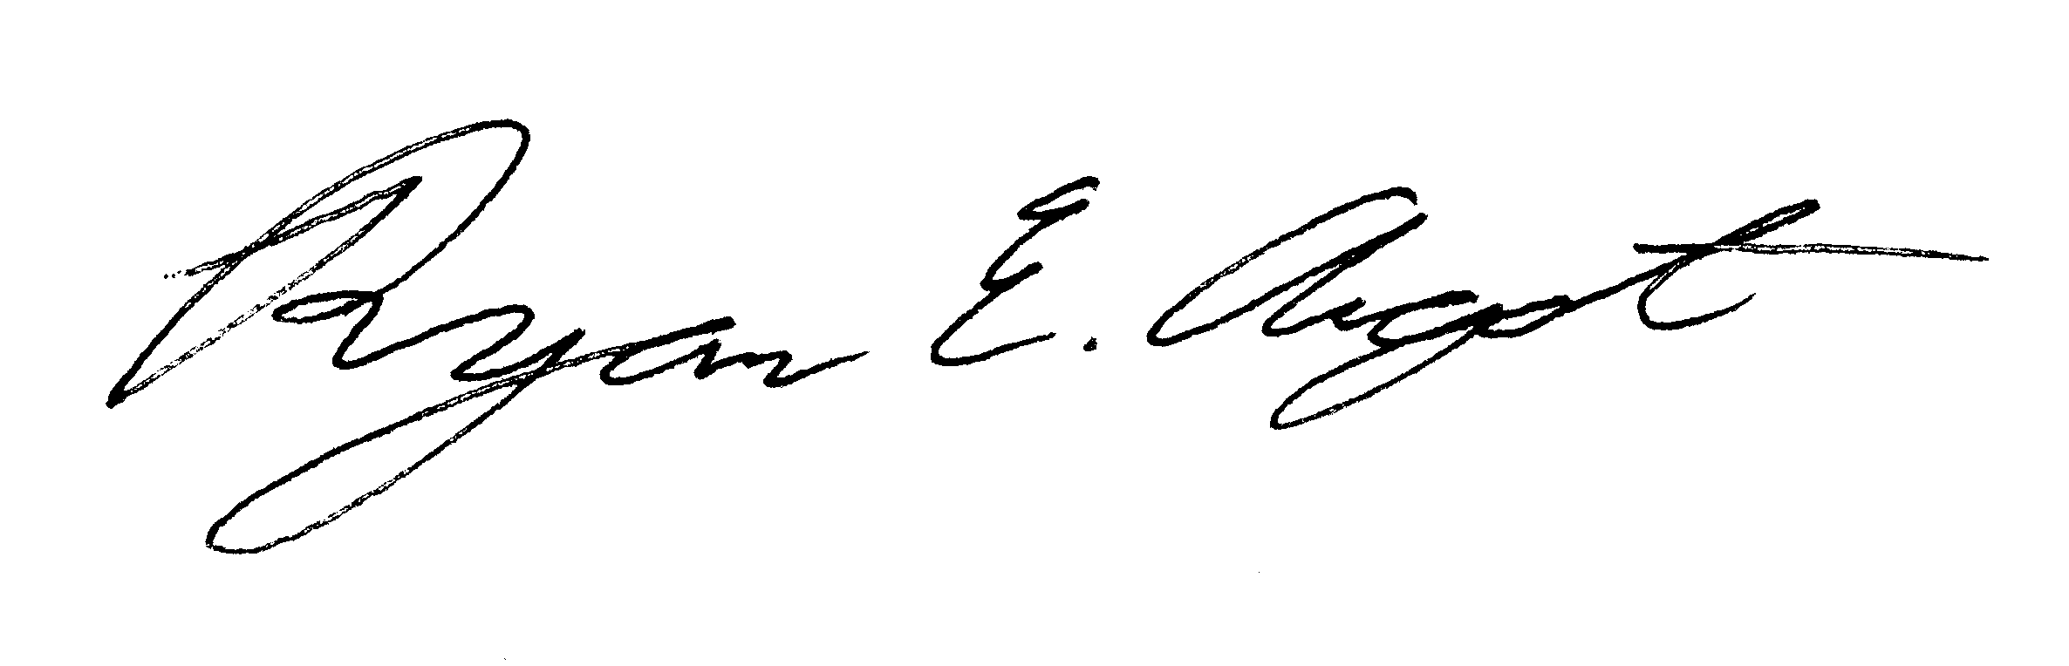 | There being no further business, President Crocenzi declared the meeting adjourned. (8:23 p.m.)  __________________________________  Dr. Ryan E. Argot, Secretary

